Analysis of the Effect Various Factors Have during the Day vs Night on Miami International Airport’s Percent Capacity Utilization

Nicholas Ho

Shreshta Phogat

Carter Sears

Gabriel Kuykendall

Omar Agha Khan

University of Maryland Baltimore County

# Abstract

This paper aims to characterize the Miami International Airport (MIA) features from May 2019 to September 2019 and identify the features that most significantly impact airport capacity utilization. It also seeks to identify any differences between the busy and off-hours at the airport and identify if there are any differences in how the variables contribute to the utilization of the airport during these times. This study will identify variables that contribute to airport congestion, such as the average aircraft delay times and the number of runway operations, and apply these to regression models to determine if their impact on the utilization of the airport is strongly correlated. In this study, regression is also used to determine if there is a reliable means for an airport to predict capacity utilization. This study determined that the strength of the factors selected to be analyzed in this experiment affects Miami Airport’s Capacity Utilization in varying amounts depending on the time of the day. It is also discovered that given the variables analyzed in this research, Miami Airport’s capacity utilization is more accurately predicted during the night while the target variable has more unpredictable variance during the day.

**Introduction**

Many factors play a role in determining the capacity utilization of an airport, including delay, weather, demand, air traffic control, airfield characteristics, and airspace characteristics. Miami international airport is the third busiest airport in the United States. “In 2019, MIA served 46 million passengers – 767,000 more than in 2018 ... international travelers rose by 575,000, [and]…domestic traffic grew by 192,000”([Miami](https://www.miamidade.gov/chambergazette/winter2020/mia-keeps-growing.page) [dade.gov](https://www.miamidade.gov/chambergazette/winter2020/mia-keeps-growing.page)). Over 100 carriers use the airport to serve international visitors and outgoing travelers to Latin America and the Caribbean. This paper is focusing on the “pre-COVID 19” pandemic time from May 2019 to September 2019 when the average daily passenger moves were 105,000 to 115,000. Although that number went down in March 2020, it quickly picked back up in July and has since gone much beyond to ~152,055 domestic and international average daily passengers ([Scheckner,](https://www.miamitodaynews.com/2020/12/01/passengers-winging-back-at-miami-international-airport/) [2020](https://www.miamitodaynews.com/2020/12/01/passengers-winging-back-at-miami-international-airport/)). As MIA continues to grow in passenger demand every year, it becomes increasingly important to mitigate problems arising from high demand and insufficient capacity. Understanding the effects of flight delays and applying operational changes or other innovations is essential in ensuring transportation efficiency. Capacity refers to the maximum number of operations that an airport can sustain in a given period, and the percentage utilization of the capacity is a metric that quantifies congestion that must be managed for an airport to continue to operate efficiently. This paper aims to determine whether or not various factors at MIA, such as the number of flight operations, the time of the day, and flight delays, are reliable for predicting capacity utilization. It also aims to determine how the effects of these variables change during the busier hours of the day compared to the calmer hours of the night in order to provide a means for airports to predict and manage capacity utilization and decrease uncertainty reliably.

**Literature Research**

One of the significant problems facing airports today is flight delay due to an imbalance between capacity, demand, and other factors. Previous research has described and analyzed these factors utilizing various models. In order to predict airport capacity, different analytical and data-driven methods have been employed previously, such as Runway Capacity Model (Blumstein, 1959), FAA Airfield Capacity Model (Swedish, 1981), and Integrated Airport Capacity Model (Kicinger, 2016). More recently, machine learning models have been employed, such as Gaussian Process Regression Model (Murça, 2018), to predict capacity for up to a 6-hour look-ahead, considering convective weather and visibility conditions. Additionally, a gradient tree boosting model to predict the Airport Arrival Rate (AAR) has been generated using wind speeds, gusts, ceiling, visibility, time of day, and previous AAR as features. (Jones,2017). Another study analyzed the impact of weather on ground stop (GS) operations at Newark Liberty International Airport (EWR) using machine learning classification algorithms for providing predictions about whether a particular ground stop alone or one combined with a ground delay program (GDP) could be applied to manage arrivals destined for EWR airport. "This modeling approach produced promising results as it yielded an 85% overall classification accuracy to distinguish the implemented GS days from the normal days without GS and GDP operations and a 71% accuracy to differentiate the GS and GDP implemented days from the GDP only days" (Wang 2014). A recent study (Figuet, 2020) looked at another indicator of delay: airplane go-arounds, standard air traffic control procedures during which aircraft approach a runway but do not land. Their research describes two potential models for predicting airplane go-arounds, microscopic and macroscopic models, which can potentially be used to understand airport capacity management better. The interaction between various factors such as "runway configuration, weather and wind condition, arrival and departure sequences, noise constraints and flight schedules" (Hargrove, 2014) has been said to impact airport capacity.

Further, real-time runway capacity estimates are essential to ensuring efficient airport operations; previously described machine learning models have been static, with difficulties capturing the complexities of the constantly changing runway landscape. To this end, researchers have brought forward a machine learning model that can use feature engineering to find sets of variables that explain runway system dynamics and learn slowly as it goes. "The capacity prediction model utilizes the Adaptive Random Forest, an online machine learning model, which shows that the models can make runway capacity prediction every hour for up to six hours for both arrivals and departures" (Guang Andy, 2021). Keeping in mind the dynamic and constantly changing environment in which airport capacity is determined, the understanding of all impacting variables as well as having up-to-date current information is fundamental.

Furthermore, to deal with gaps in capacity, one of the critical steps that have been previously taken is demand management. Some steps that airports take to manage demand include reallocating demand to other airports or transport modes, economic measures such as congestion pricing, and slot scheduling (Airports commission 2013). Slot scheduling has become a more popular method that gives airline carriers the full range of airport infrastructure on a specific day/time for landing and take-off. "A slot scheduling approach brings promises to cope better with congestion problems in short to medium run and in a more sustainable way based on existing resources" (Zografos, 2017).

# Dataset Description

This research will attempt to determine the relationships between various airport delay factors and capacity utilization by using an assortment of datasets. These datasets were provided by the Aviation System Performance Metrics (ASPM) online access system, which records flights to and from designated ASPM airports. This data is stored to analyze performance metrics and provides vital data such as runway operation demand and various aircraft-related delays. These features likely contribute to the total percentage of the airport's utilization and will help us conclude with our analysis.

We will be analyzing the Miami International Airport, specifically its performance during the summer of 2019. The data we are using is a window of records of the flights captured from the start of May to the end of September.

Airport capacity is a measurement of throughput, so to reflect this unit correctly, our datasets are aggregations of flight records grouped by the hour. This grouping provides us with data that is in per-hour measurements. We utilize two datasets that follow this structure.

The first dataset contains in-depth details regarding aircraft scheduled arrivals, departures, and delays. It includes the aggregated count of on-time and scheduled arrivals and uses these values to compute delays. It also includes some columns computed using the aggregation of the records, such as average taxi-out times during each hour of the day. This information allows us to draw relationships between arrivals, departures, delays, and capacity. It also shows how much the runways are being utilized for a given hour of the day which can help identify inefficiencies and possible solutions to increasing or reducing the capacity utilization. Note that this dataset does not include general aviation and military flights in the total values.

The second dataset contains details about the airports' efficiency rates, operation demands, and utilization metrics. While the previous dataset focuses on delays, this dataset focuses on the relationships between demand units and actual arrivals and departures. This data allows us to track the demand for arrival or departure operations and compare it to the actual number of operations that take place. These values will be key for making predictions of the airport's utilization. Unlike the previous dataset, this dataset includes general aviation and military flights in the column values, providing a more comprehensive utilization metric for the airport.

**Methods**

Across these two datasets, there are over 35 columns to analyze. Only the features that are relevant to the study should be accounted for. For this study, we are interested in looking into the hour of the day, the number of flight operations, and any kind of delays an aircraft may face as it is preparing to take off. This allows us to reduce the number of features in our dataset to only the ones that fall into one of these categories.

After reducing the width of the dataset, the dataset was split into two parts, one to represent the daytime operations of the airport and one to represent the nighttime. What we wanted to capture with this split is a division between the busier hours of the day and the calmer hours in order to compare how the airport operates during both periods. To determine where the busy and calm hours lie within the day, we plotted the distribution of flights over 24 hours (Figure 1).

**Figure 1**

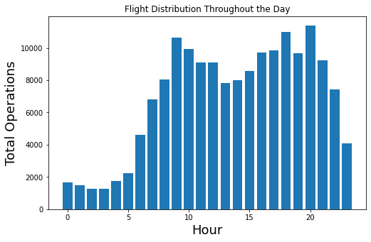

The distribution shows us that the first peak of the day occurs at 9 am while the last peak occurs at 8 pm, where it continues to drop until it reaches its lowest point at 3 am the following morning. Using these two peaks as the point where we divide the daytime dataset from the nighttime dataset allows us to create two even sets that represent 12 hours of the day each. Using these datasets, the differences between the strength of the features during the daytime and nighttime can be determined.

Nevertheless, even after narrowing the features to this smaller set, we still have 11 variables. Regularization can be used to decrease the complexity of a model with this many features. For our project, we decided to use a Lasso regression model in order to determine the strength of the correlation between the various features and the airport’s capacity utilization. After splitting the data into a training and test set, the Lasso regression model was trained, allowing us to determine the coefficients for each variable. First, we started with the daytime dataset.

Lasso Coefficients

Date : -0.005427287229501093

Hour : 0.0

Total For Efficiency Computation : 0.5916842124011285

Total Demand Units : 0.13508556701250593

Average Gate Departure Delay : 0.057322558960900404

Average Taxi Out Time : -0.0

Average Taxi Out Delay : -0.061491974488589805

Average Airborne Delay : 0.12215846264818347

Average Taxi In Delay : -0.0

Average Block Delay : 0.0

Average Gate Arrival Delay : -0.0

The variables in which the coefficients were reduced to zero were determined not to have a strong enough relationship with the Capacity Utilization compared to coefficients that had non-zero values. The variable with the largest coefficient was Total for Efficiency Computation, representing the total number of runway operations per hour. This includes all observed departures and arrivals. The next step will drop the zero value coefficients from the training and predictions.

Lasso score on test data: 0.8516018873105977

The R squared score was also calculated to determine how strong the correlation between all of the independent variables was on the capacity utilization. A value of 0.85 is substantial and confirms for us that the remaining variables combined have a strong correlation to the dependent variable. Next, we continued the same process for the nighttime set.

Lasso Coefficients

Date : -0.0019582794718567796

Hour : 0.0

Total For Efficiency Computation : 0.7249970076200313

Total Demand Units : 0.03962851566213124

Average Gate Departure Delay : 0.0010116061968460793

Average Taxi Out Time : 0.0

Average Taxi Out Delay : 0.0

Average Airborne Delay : 0.0

Average Taxi In Delay : 0.0

Average Block Delay : 0.0

Average Gate Arrival Delay : 4.429134710236983e-05

Overall, the number of variables reduced to zero for the nighttime set has increased from the daytime set. Most of the variables with coefficients from the daytime set also have coefficients in the nighttime set, but Average Taxi out Delay and Average Airborne Delay no longer contribute enough to the target for Lasso to consider. Instead, the Average Gate Arrival Delay has developed a small, non-zero coefficient. Overall, the variables tend to contribute less to the target except for Total for Efficiency Computation which has seen a significant increase. This increase shows that during the calmer hours of operation, the Total for Efficiency Computation determines most of the variation in Capacity Utilization.

Lasso: Lasso score on test data: 0.993985746493672

The model trained with the nighttime set also had its score computed. The R squared score for the nighttime set was much stronger than the daytime set, with a value very close to 1. The coefficient for Total for Efficiency Computation is much more significant with the nighttime set and contributes more to the Utilization Capacity, which can explain how the variables can be more responsible for the variability in the target.

# Analysis

After the significant variables for both the daytime and nighttime datasets have been determined using a Lasso Model, the data can be predicted using ridge regression. The datasets had the variables with coefficients of 0 dropped from the data frame and were used to train ridge regression models. Based on these models, capacity utilization could be predicted and plotted against the remaining variables to visualize the relationship's strength.

For the daytime dataset, the variable with the strongest correlation was determined to be the Total for Efficiency Computation. The predicted target values were used with the test variables from the data split in order to create a scatter plot. The plot for this variable shows that there is indeed a robust linear relationship between the two values (Figure 2). Analyzing the trend allows us to predict the maximum Total for Efficiency Computation that the airport is able to handle before the airport reaches 100% capacity utilization. For other variables such as Average Gate Departure Delay, it is much harder to recognize any linear trend and make a prediction (Figure 3).

**Figure 2**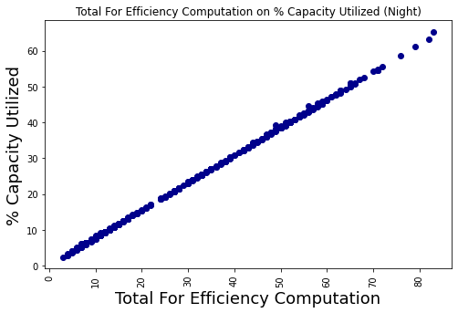

**Figure 3**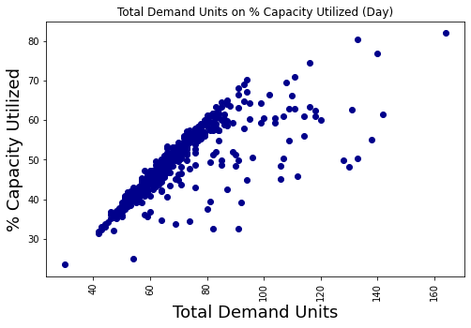

Total Demand Units also appear to have a strong linear relationship with the Capacity Utilized (Figure 4).

**Figure 4**

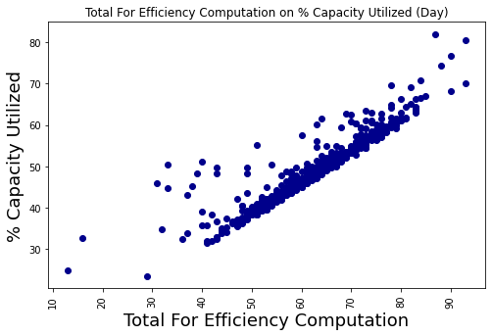

For the nighttime model, the Total for Efficiency Computation is visibly much more potent as a predictor for the Capacity Utilization than during the day (Figure 5). Total Demand units also have a much stronger relationship than the daytime model (Figure 6).

**Figure 5**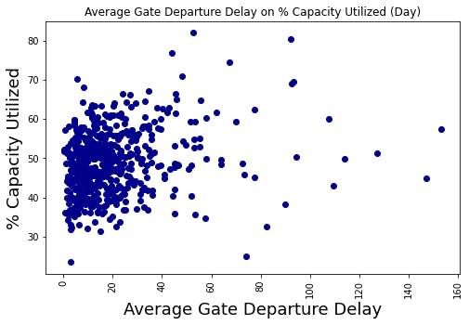

**Figure 6**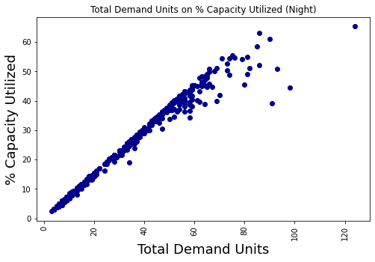

**Figure 7**

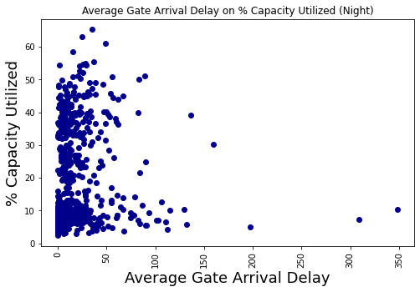

However, the contributions from the delay variables for the nighttime model are even less than during the day, and almost no linear relationship can be distinguished from the Average Gate Arrival Delay scatter plot (Figure 7).

**Results**

The Lasso Regression score for the daytime data set had an R squared value of 0.851, while the score for the nighttime dataset had a value of 0.993. The difference in these scores shows that the variables we have selected for this experiment have less of an effect on the airport's Capacity Utilization during the day than during the night. Almost all of the changes in the Capacity Utilization can be explained by the selected variables for the nighttime model, while the daytime model has some variability not accounted for in the selected data. This variability could be due to the other variables that have been excluded from the research playing a more prominent role in determining Capacity Utilization than we had expected or because operations during the day are less predictable for other reasons. In contrast, with an R squared score of almost 1, nearly all capacity utilization is attributed to the variables we have selected for the nighttime dataset.

The Total for Efficiency Computation is the main predictor for the daytime and nighttime model. This assertion makes sense because as the number of arrivals and departures increases, the airport's runways will experience higher traffic and thus increase the Capacity Utilization of the airport. The coefficients for Total for Efficiency Computation show that the variable's effect on Capacity Utilization is much stronger at night than during the day. The scatter plot for the two variables at night is almost perfectly linear, showing how capacity utilization can almost entirely be predicted by the Total for Efficiency Computation during the night, while the scatter plot for the daytime model has more variance in the plot points.

Total Demand Units is another strong predictor in both of the models, as shown by its apparent linear relationship in the scatter plots, but while it is strong, the smaller coefficient shows us that it still has a weaker relationship to the target than the Total for Efficiency Computation. While the Total for Efficiency Computation is the actual number of arrivals and departures, the Total Demand Units variable only represents the demand for arrivals and departures. It makes sense that the actual number of operations is the stronger predictor, but Total Demand Units still has a critical value. Demand units can be determined ahead of time by the airport by examining the flight schedule, while the actual arrivals and departures cannot be predetermined. Determining demand ahead of time would allow the airport to make reasonable Capacity Utilization predictions before the actual number of arrivals and flights is known by using the scheduled demand.

The much weaker predictors are the various flight delays. It is hard to recognize any linear relationship between Capacity Utilization and the delay variables from the scatter plots. In fact, many of the delay variables were eliminated by the Lasso model. However, while their coefficients are very small, they do exist according to the results from the Lasso model. These results suggest that the delay variables contribute a minimal amount towards the target variable, much smaller than expected. Perhaps a better experiment would have been to see if the combination of these delays contributes more to the capacity utilization as opposed to each one individually. The interesting point about these variables found through this observation is that their effect on the target varies between the daytime and nighttime models. The only delay variable that exists in both models is the Average Gate Departure Delay. The daytime model is affected by Average taxi Out Delays and Average Airborne Delays, an issue that the nighttime models do not face. In contrast, the nighttime model exclusively suffers from Average Gate Arrival Delays.

# Conclusion

In conclusion, using the variables that we have selected for this research, it is easier to predict the airport's Capacity Utilization during the night than during the day. The variables we have selected account for almost all of the change in the Capacity utilization during the night, while there is still some variation in utilization unaccounted for during the day. This determination means that flights at night are more predictable than flights during the day, given the factors we examined here. The best predictor for Capacity Utilization was Total for Efficiency Computation which could almost predict the target on its own for the nighttime model. This idea suggests that congestion is not an issue at night, and the utilization of the airport directly correlates to the number of arrivals and departures. The next strongest predictor was the Total Demand Units which, while not as strong as the Total for Efficiency Computation, can be calculated ahead of time by the airport and be used as a rough predictor for future Capacity utilization.

The Delay variables, which were expected to have been an indicator of congestion and high utilization, did not have as significant an impact as expected. Perhaps this is because we had looked at each delay individually, while a summation of all the delay times would have produced a better result. When it comes to determining the airports' Capacity Utilization, it may be better to look at the total value of the delay instead of where the delay occurred.

Another feature to further explore is to try perhaps adding weather conditions into the equation. This feature could have helped explain some of the variances in capacity utilization as weather affects runway configurations, limiting the number of available runways, thus reducing the airport's capacity.

Using the information gathered through this research, airports can begin to explore means of developing models to reliably predict Capacity Utilization during the day and night to help manage congestion and efficiency.

**References**

Airports Commission. (2013). Interim report.

http://www.gov.uk/government/uploads/system/uploads/attachment_data/file/271231/airports-commission-interim-report.pdf. Accessed December 22, 2014.

Blumstein, A. (1959). The landing capacity of a runway. *Operations Research*, *7*(6), 752–763.

https://doi.org/10.1287/opre.7.6.752

Consulting, F., & Rakas, J. (2014). Defining and measuring aircraft delay and airport capacity

thresholds. *Airport Cooperative Research Program*. https://doi.org/10.17226/22428

Figuet, B., Monstein, R., Waltert, M., & Barry, S. (2020). Predicting airplane go-arounds using

machine learning and open-source data. *Proceedings*, *59*(1), 6. https://doi.org/10.3390/proceedings2020059006

Guang Andy, L. J., Alam, S., Piplani, R., Lilith, N., & Dhief, I. (2021). A decision-tree based

continuous learning framework for real-time prediction of runway capacities. *2021 Integrated Communications Navigation and Surveillance Conference (ICNS)*. https://doi.org/10.1109/icns52807.2021.9441617

Jones, J. C., & DeLaura, R. (2017). Predicting airport capacity in the presence of winds. *17th*

*AIAA Aviation Technology, Integration, and Operations Conference*.

https://doi.org/10.2514/6.2017-3595

Kicinger, R., Chen, J.-T., Steiner, M., & Pinto, J. (2016). Airport capacity prediction with

explicit consideration of weather forecast uncertainty. *Journal of Air Transportation*,

*24*(1), 18–28. https://doi.org/10.2514/1.d0017

MIA Keeps Growing. (2021). Retrieved December 9, 2021, from

https://www.miamidade.gov/chambergazette/winter2020/mia-keeps-growing.page.

Murça, M. C., & Hansman, R. J. (2018). Predicting and planning airport acceptance rates in

Metroplex systems for improved traffic flow management decision support.

*Transportation Research Part C: Emerging Technologies*, *97*, 301–323. https://doi.org/10.1016/j.trc.2018.10.020

Scheckner , J. (2020, December 2). *Passengers winging back at Miami International Airport*.

Miami Today. Retrieved December 9, 2021, from

https://www.miamitodaynews.com/2020/12/01/passengers-winging-back-at-miami-international-airport/.

Swedish, W. J. (1981). *Upgraded Faa airfield capacity model. volume 2. technical description of*

*revisions*. Defense Technical Information Center.

Wang, Y. (2014). Analysis and prediction of weather impacted ground stop operations. *2014*

*IEEE/AIAA 33rd Digital Avionics Systems Conference (DASC)*.

https://doi.org/10.1109/dasc.2014.6979510

Zografos, K. G., Madas, M. A., & Androutsopoulos, K. N. (2016). Increasing airport capacity

utilisation through optimum slot scheduling: Review of current developments and identification of future needs. *Journal of Scheduling*, *20*(1), 3–24. https://doi.org/10.1007/s10951-016-0496-7